ME-Eye Idol-2

EYE IDOLS

Below is an Eye Idol made of baked clay (Fig 21) and dating to the later fourth millenium BC (circa 3500-3300 BC), the Uruk period. Eye Idols look remarkably modern, and are simple and abstract. They represent the human form, usually with a flat body and oversized eyes. Four thousand of these figurines were found in a monumental building known as the 'Eye Temple' in Tell Brak, at the site of the ancient city of Nagar in north-eastern Syria. This was officially excavated by Max Mallowan, the second husband of Agatha Christie, who also accompanied him on digs there in 1937-8. More recent excavations have dated the Eye Temple even earlier, with the Oates exploration giving a date of 3900 BC. The site is one of the largest in Mesoptamia, covering an area of some 40 hectares, and rising to a height of 40 metres and one of the ealiest urban centres in Mesopotamia, and indeed the world. The Eye Temple would have been an enormous building, of which only a small portion has been excavated. This building has a massive entranceway with a basalt doorsill and towers on either side, red mud brick walls which are 1.85 meters thick, and even today stand 1.5 meters tall. Radiocarbon dates have placed this structure securely between 4400 and 3900 BC.

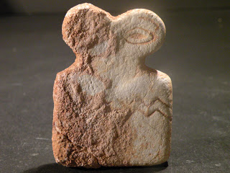

Fig 21 (height 7cm)

The idols themselves vary in size from about 3 to 6 cm in height, and are made of various stone materials (limestone, soapstone and alabaster) or baked clay, and many were incorporated into the mortar of the mud brick walls with which the temple was constructed. The mortar adhering to areas of Fig 15 is clear to see. The interior decoration of the "Eye Temple" was lavish with the altar decorated by a frieze made from colourful stones, silver nails and gold foil, and on the floor and walls were mosaics made from coloured clay cones. Eye imagery and designs are found in the frieze and carvings in the temple, suggesting that the eye was a powerful magical and religious symbol. The large number of Eye Idols found, and their size, suggests that they were left in the temple as votives offerings (gifts to the gods), perhaps representing the people who dedicated them as offerings. This makes the name "eye idol," a misnomer,if the image represents a worshipper. The term "eye idol" probably came from a competing theory, proposed by Mallowan, that they represented the Sumerian fertility goddess Inanna (and thus were idols). Inanna was later identified with the Semitic goddesses Ishtar and Astarte. It could be that the same general image served the purposes of both votive and idol, with worshippers fashioning figurines of themselves patterned after their eye goddess, offering themselves to her. Wide eyes may represent the worshipper's attentiveness to the gods, and vica versa, as has been claimed more generally in Mesopotamian art. Sometimes the "wide eyes" are linked to sexuality and excitement too, and this may provide a connection to fertility. The decoration of the idols varies, and it seems that they may have been personalised. Some have carved lines and zig-zags on their bodies, as the example below (Fig 21), perhaps depicting clothes. Others are examples of group idols, representing more than one figure, some of which have a smaller 'child' figure carved onto the front.  
  
  
Although Tell Brak is in north-eastern Syria, both the decoration and plan of the Eye Temple resemble that of south Mesopotamian temples, such as those in Uruk and Eridu. Eye symbolism was also popular in Mesopotamia around this time, and eye designs have been found on objects from the Royal Cemetery and temples at Ur. The Eye Idols of Tell Brak, however, are completely unique and have no parallels, in either Syria or Mesopotamia according to the Fitzwilliam Museum.

Below is a second example of an Eye Idol of a very different form (Fig 22). It is a bell shaped marble idol, with drilled-through eyes. This form has been found at a number of sites in northern Mesopotamia, particularly in other parts of Syria, though not at Tell Brak, and is less common than the Tell Brak idols.

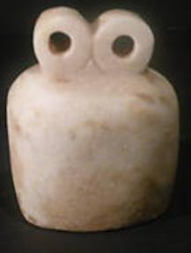

Fig 22 (height 8.5cm)